Creating a Public S3 Bucket on AWS

Objectives:-

Create a bucket in Amazon S3

Add an object to a bucket

Manage access permissions on an object and a bucket

Create a bucket policy

Use bucket versioning

Step 1 — Navigate to Amazon S3
Log in to the AWS Management Console and navigate to Amazon S3 via the Services menu. The S3 homepage displays a Create a bucket .
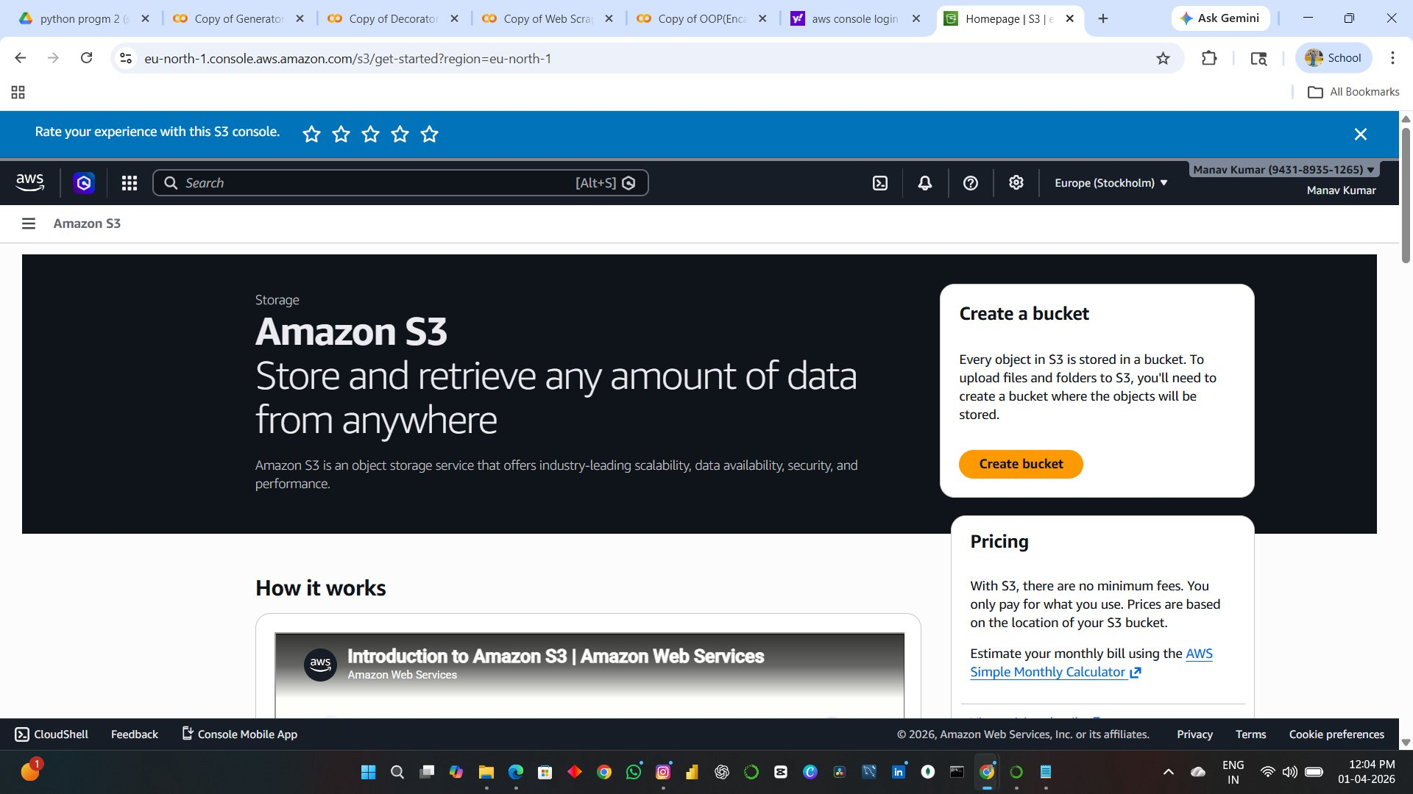

Step 2 — Configure Bucket Name and Type
On the Create bucket page, fill in the General configuration section with the following settings:
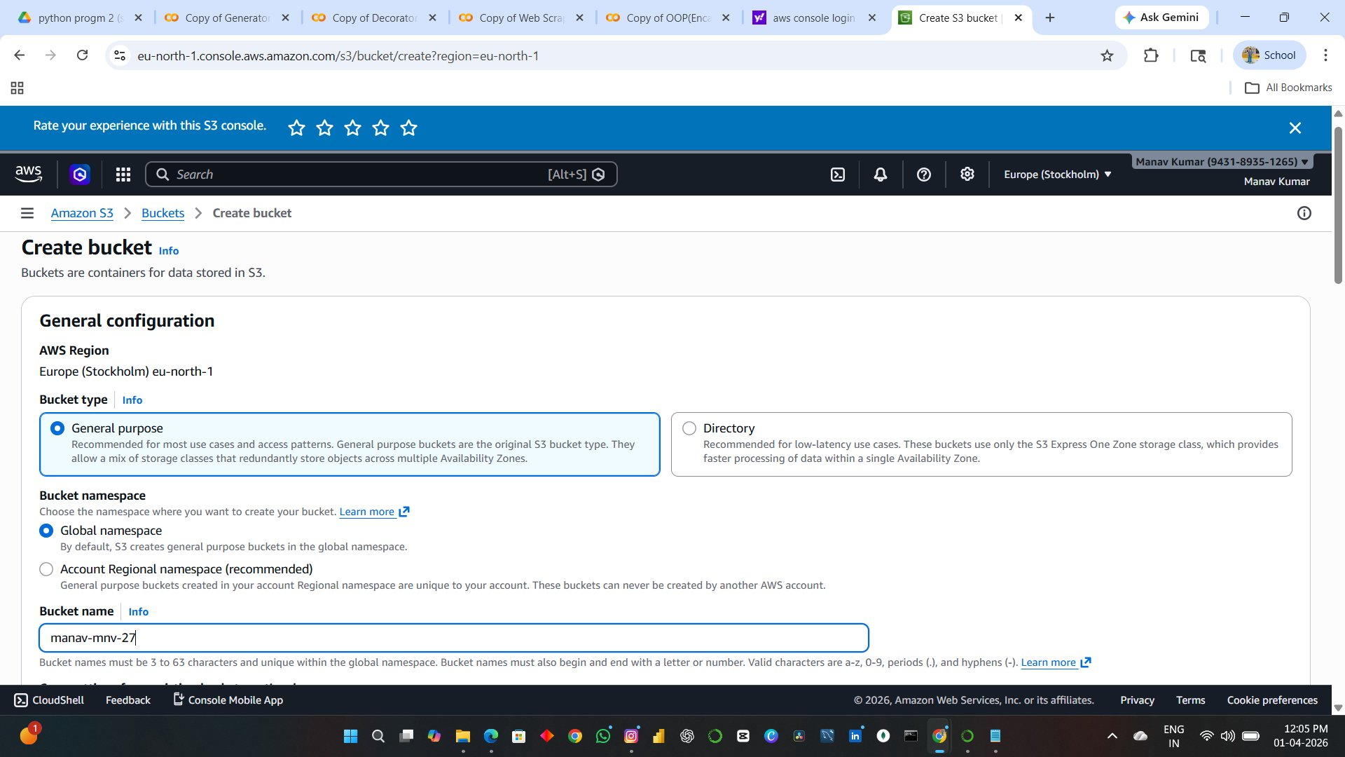

Step 3 — Enable ACLs (Object Ownership)
Scroll down to the Object Ownership section. For a public bucket, select ACLs enabled.
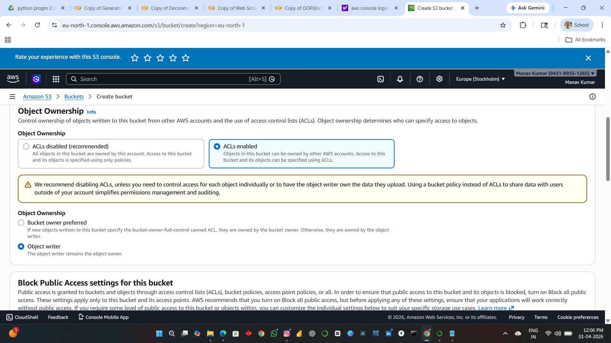

Step 4 — Disable Block Public Access
In the Block Public Access settings section, uncheck Block all public access. A warning appears — check the acknowledgement box confirming you understand the bucket and its objects may become public.
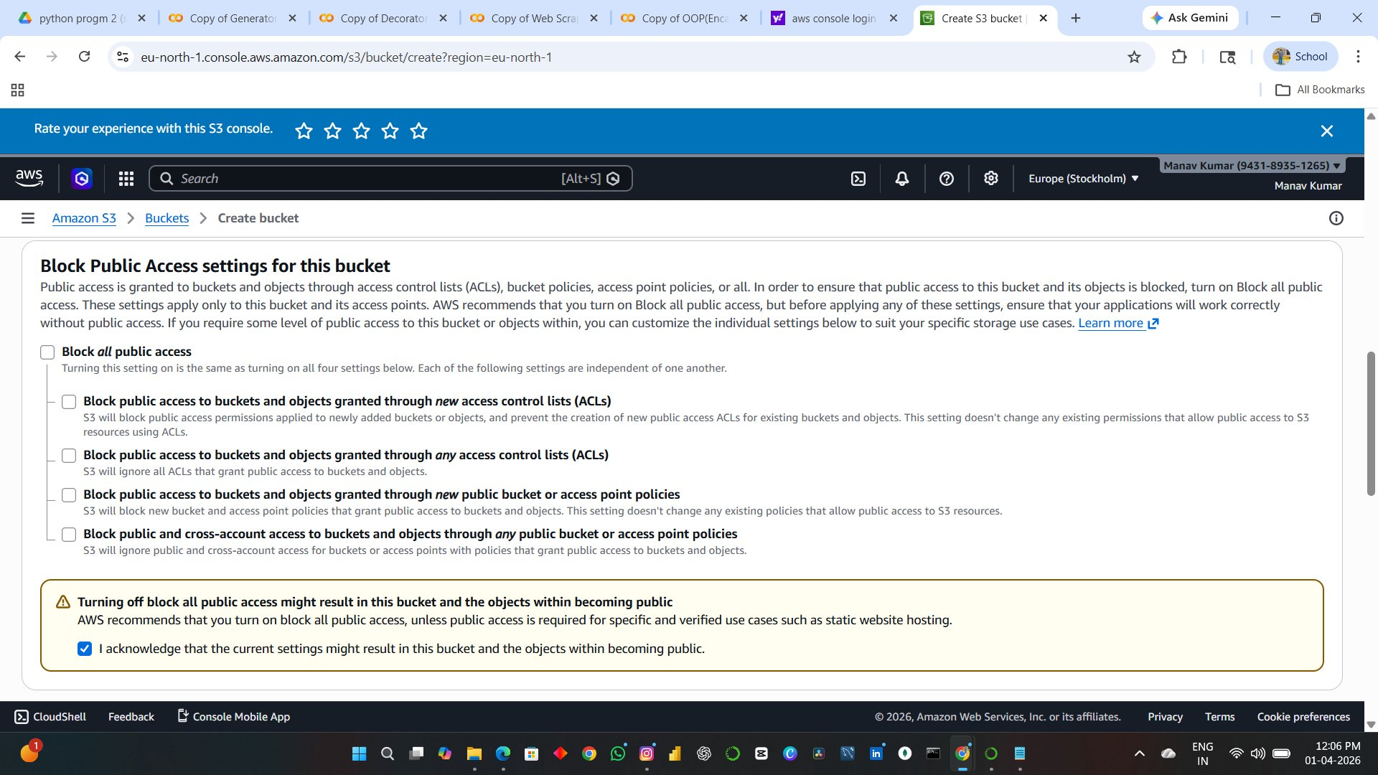

Step 5 — Bucket Versioning and Tags
Scroll further to Bucket Versioning. For this bucket, versioning is set to Disable.Click Create bucket at the bottom of the page.
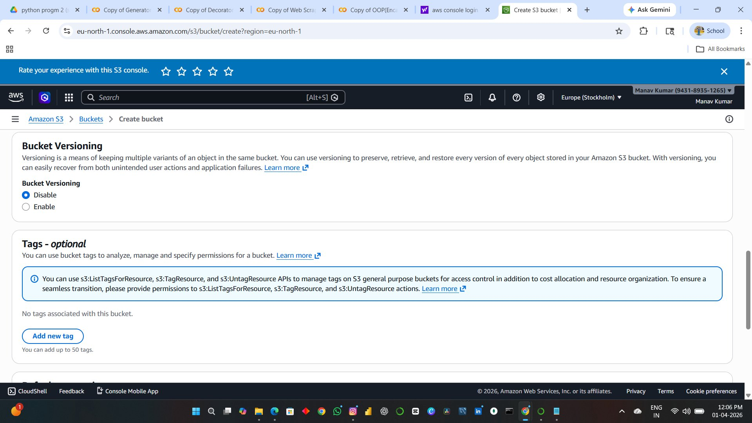

Step 6 — Default Encryption
The Default encryption section configures server-side encryption for all new objects stored in the bucket. Keep the defaults and then click Create bucket.
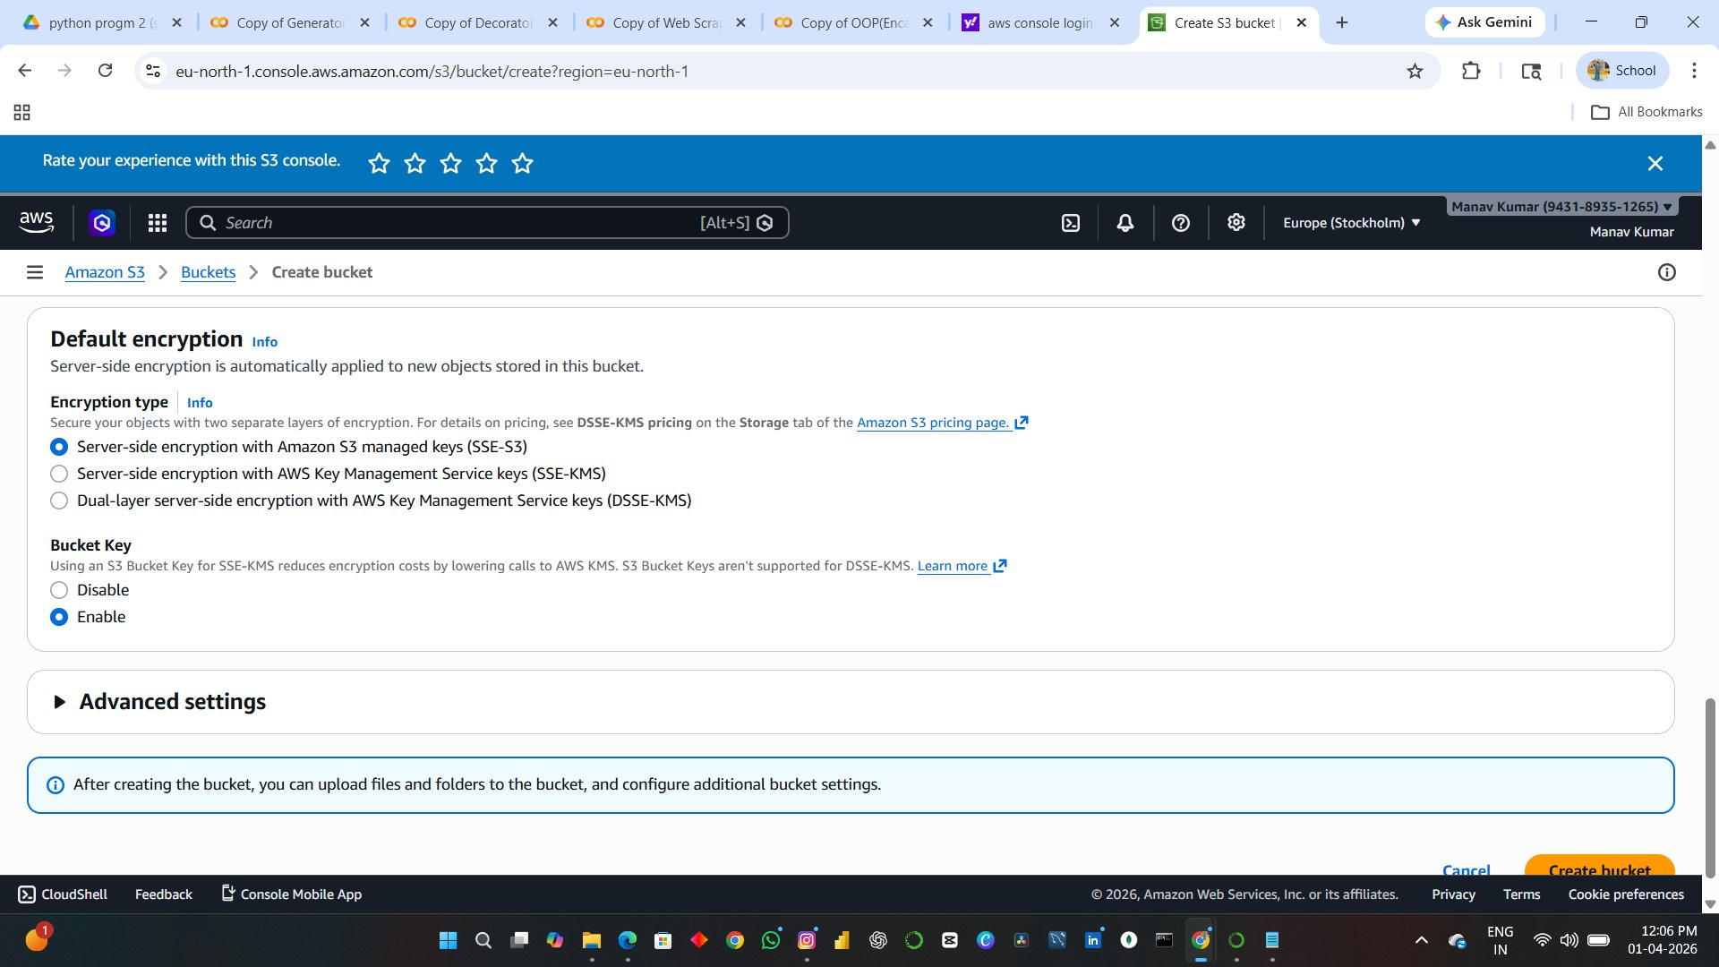

Step 7 — Upload an Object
After the bucket is created, navigate into manav-mnv-27 and click Upload. Add the file and confirm the destination is s3://manav-mnv-27.
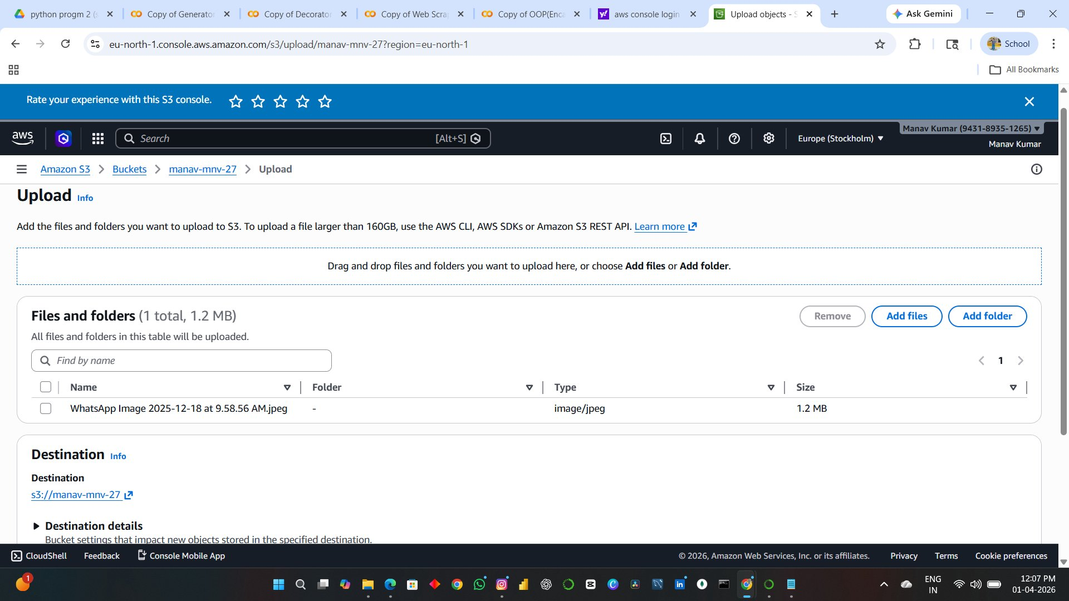

Step 8 — Upload Succeeded
After clicking Upload, the Upload: status page confirms the result with a green success banner.
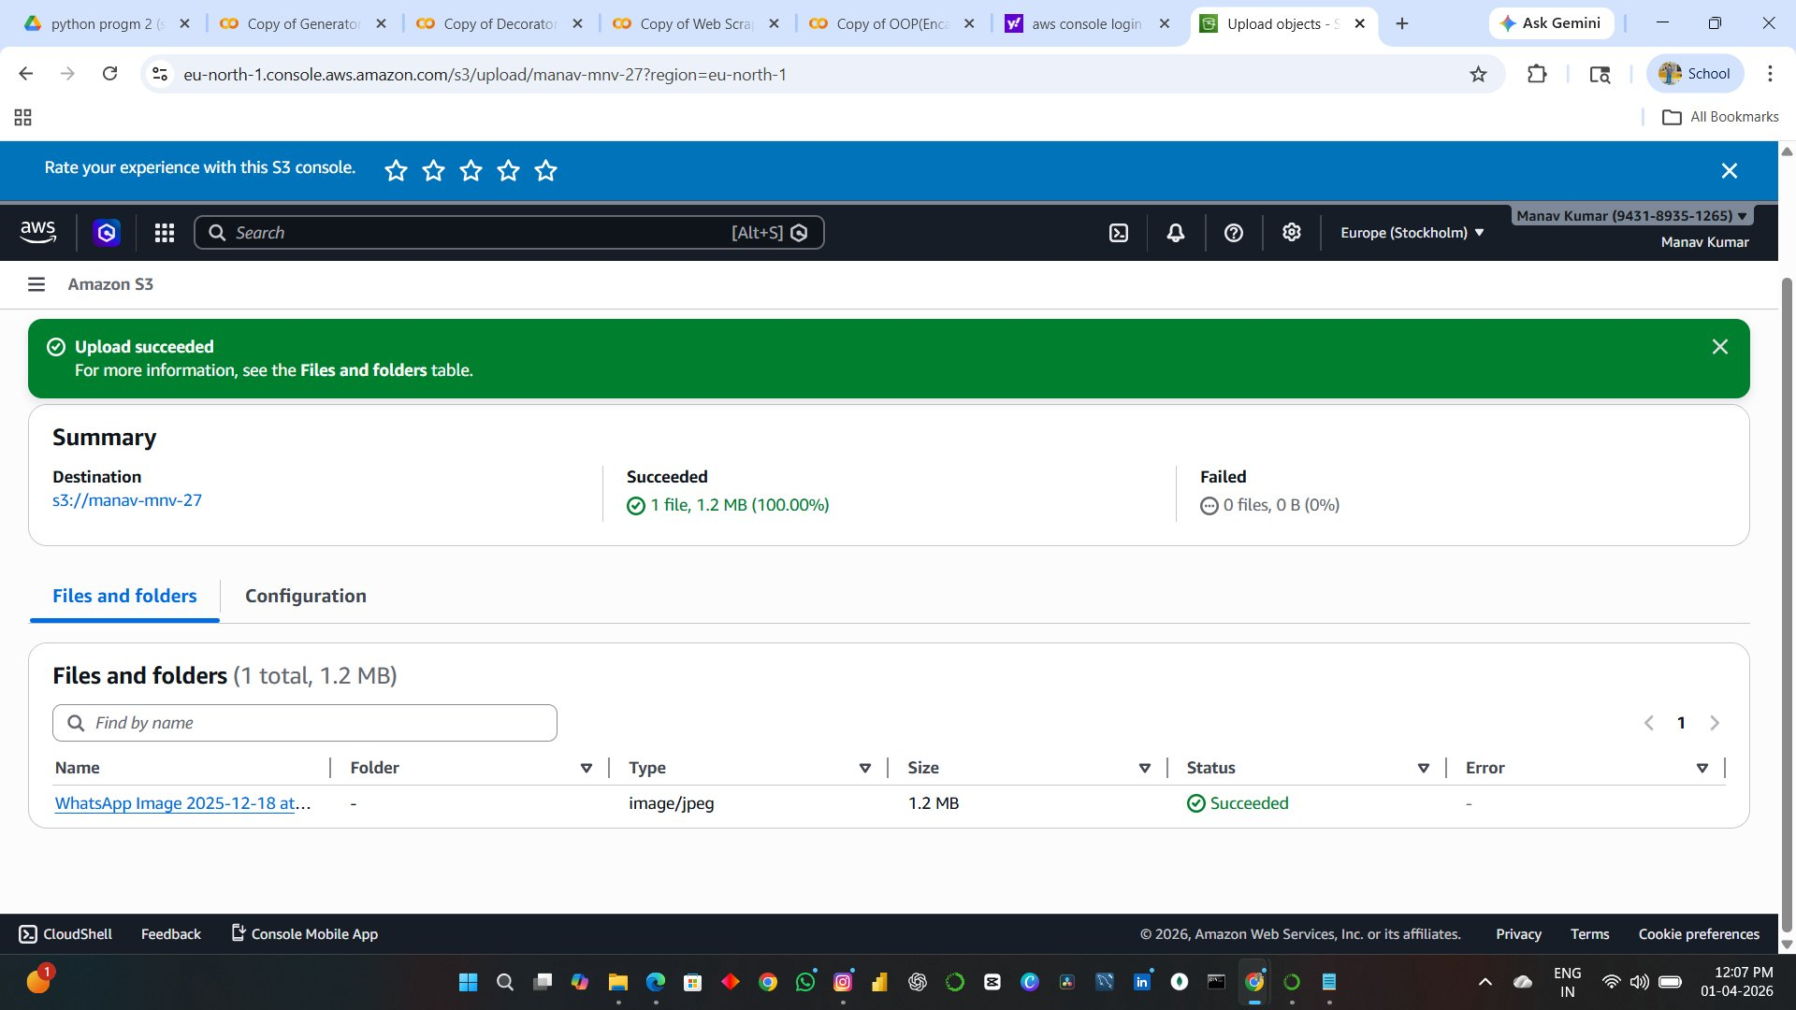
Step 9 — View Object Details and Make Public Using ACL
Click on the uploaded object to open its Properties panel.. To make the object publicly accessible, click Object actions and select Make public using ACL.
